AIRPORT TUŘANY – BRNO - http://www.brno-airport.cz/en/
The nearest airports are in Brno, Prague, Vienna or Bratislava. International Airport Brno-Tuřany is regularly served by flights from London (Stansted), Milan (Bergamo) and Munich. There are many seasonal flights to and from the Greek islands, Egypt, Spain, Turkey, and Bulgaria. To get to Brno-Hlavní nádraží (Brno’s central railway station) and Brno-Zvonařka (bus station) you can use lines E76 with buses running every 30 minutes, or N76 (night). The journey takes around 20 minutes.
Other possible connections are via Vaclav Havel Airport in Prague, Wien-Schwechat Airport in Vienna or Bratislava Airport. Buses heading downtown to train and bus stations are available at the airport terminals.

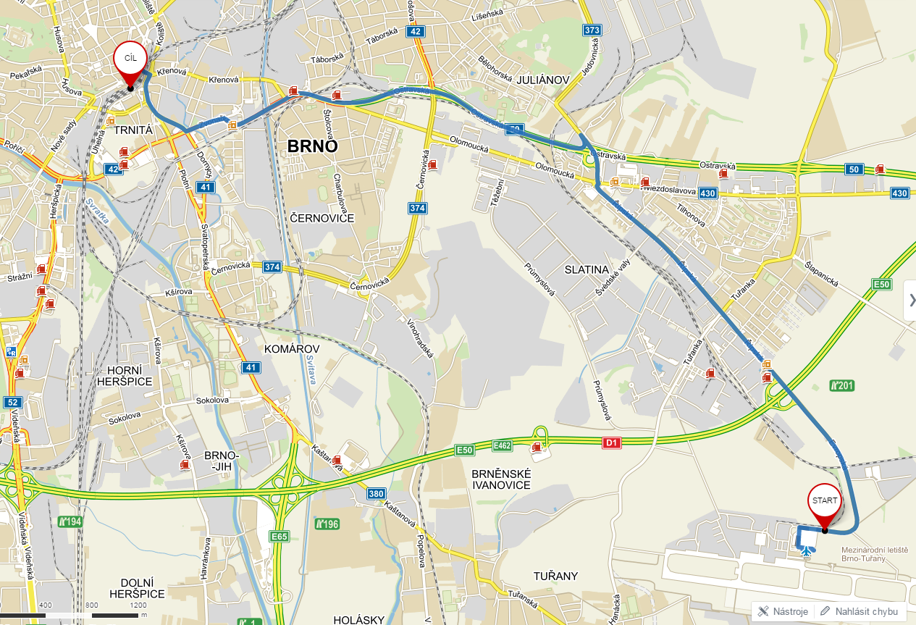
FROM THE AIRPORT use the city bus E76 and go about 20 minutes to its final stop - Brno Main Train Station. You need to buy a ticket for 25 CZK - 1 € at the counter in the departure hall or at the vending machines in the arrival hall.
Next to hotel Grand station there is a Main train station and in front of it there are tram stops. You will go by tram # 2 to STARA OSADA TERMINAL (journey will take approximately 11minutes) and then walk to Unihotel Čejkova. You need tram ticket for 60minutes / 25,- CZK. Buy a ticket in machine for tickets on tram stop or in news stand near the tram stops.

Brno Main Train Station

Airport

