Way from CEITEC Bohunice Kampus to Immigration Office

Foreigners from outside the EU and EFTA must register within 3 working days of their arrival in the country Immigration Office - OAMP (long-term visas and residency permits) on address: Hněvkovského 65, Brno

Way from CEITEC Bohunice Kampus to Immigration Office is shown on the pictures bellow.
You will need to use two buses, the way is about 30minutes long.
- Bus #61 from Kampus sever to Úzká (blue line on picture bellow)
- Bus #40 from Úzká to Hněvkovského (red line on picture bellow)

Picture 1) Overview of transport from Kampus to Immigration Office.
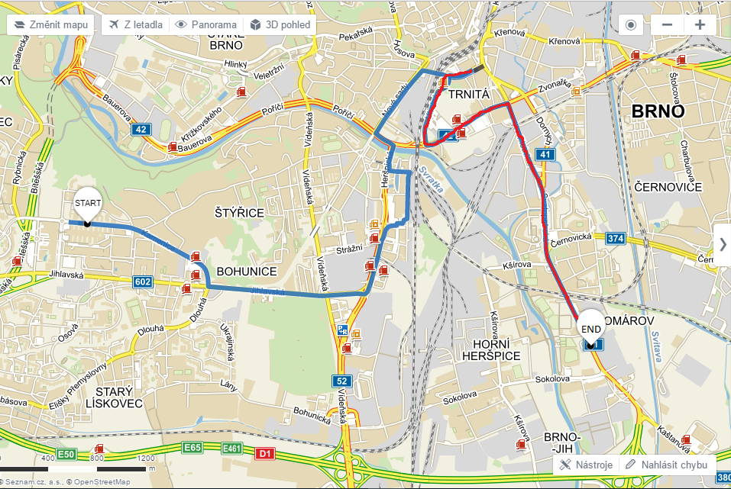

PICTURE 2) change buses from #61 (blue line) to #40 (red line). You will need to cross the street and find #40
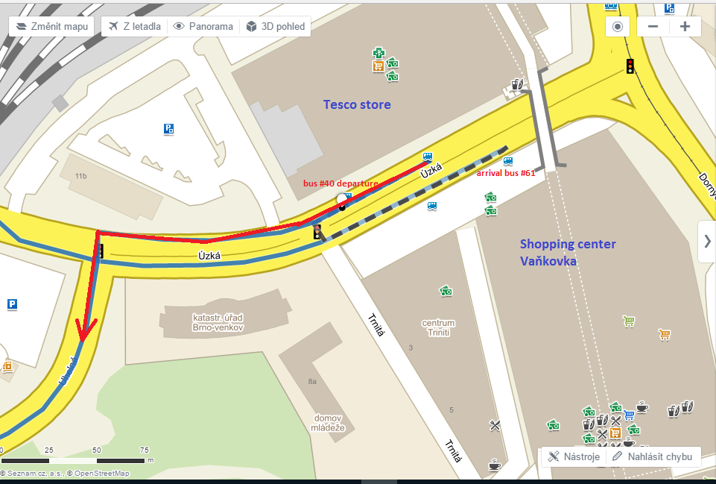

PICTURE 3) Detail map of Hněvkovského bus stop (you have to press bus sign and then bus stops) and way to Immigration Office
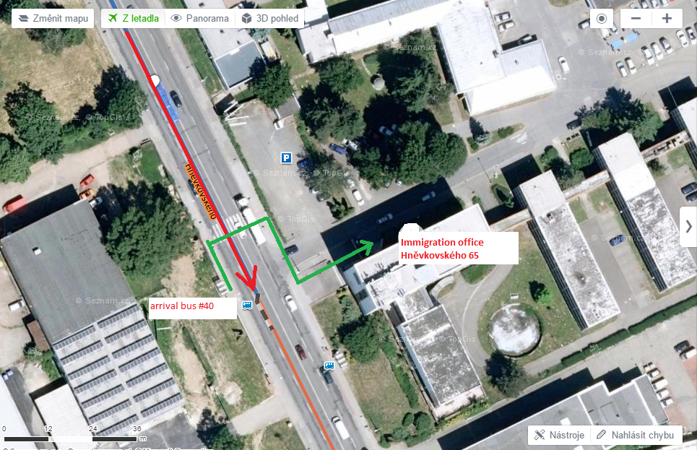
OAMP

