The Čejkova UNI Hotel - https://www.skm.muni.cz/hotel/uni-cejkova?en

This building in Brno-Židenice provides long-term accommodation of foreign lecturers and MU guests. Most rooms are single bed with an ensuite bathroom. A common room with a TV set, a furnished kitchen and a laundry room is available for our guests. You can also sit back and relax in the garden or the atrium. There is also WiFi eduroam in the building via the WiFi eduroam technology. Reception is open on work days from 7.00 AM to 3.00 PM. Accommodation is possible only by prior appointment.

You can find us
Near the railway station in Brno-Židenice. The connection from Mendlovo nám. (square) by trolleybus No. 25 and 26 (Židenice kasárna stop), from the main station by tram No. 2, from Česká street by tram No. 3, (Stará Osada terminal) - find on the map

Information and bookings
Šoustalová Helena: | 549 49 8291
e-mail: | uni.cejkova@skm.muni.cz

Contact information
address: | Čejkova 2850/21, 615 00 Brno
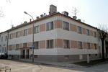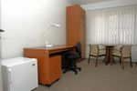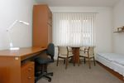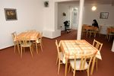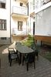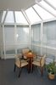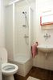

The Čejkova UNI Hotel

Information and bookings
Šoustalová Helena: | 549 49 8291
e-mail: | uni.cejkova@skm.muni.cz

Contact information
address: | Čejkova 2850/21, 615 00 Brno

You can find us:
Near the railway station in Brno-Židenice.
Connection from Mendlovo nám. (square) by trolleybus No. 25 and 26 (Židenice kasárna stop), from the main station by tram No. 2, from Česká street by tram No. 3, (Stará osada terminal)

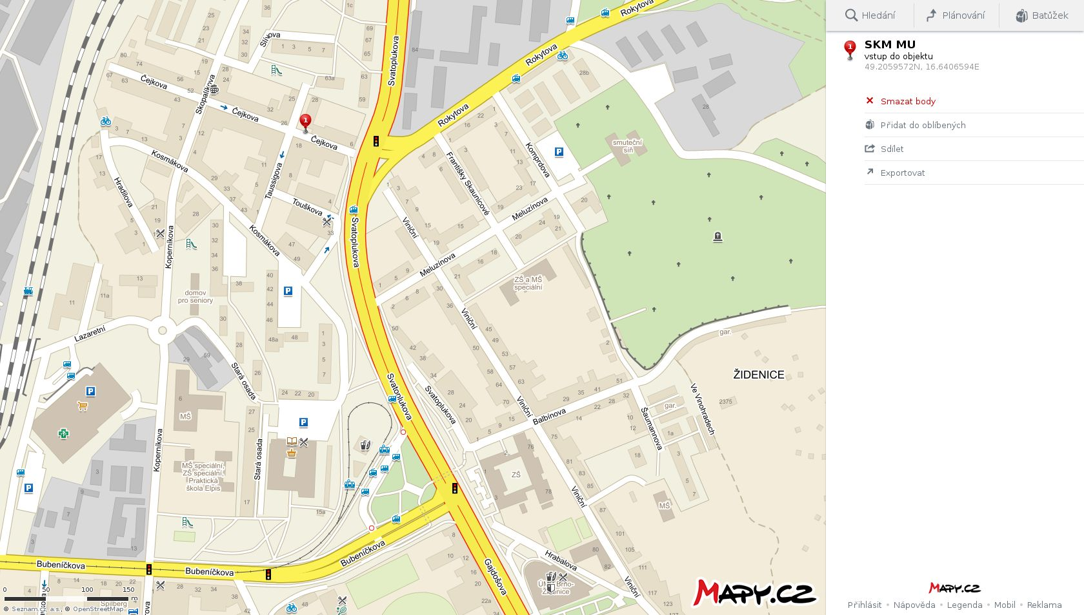
TROLEYBUS STOP SVATOPLUKOVA # 25
BRNO CENTRE
TRAM STOP STARÁ OSADA # 2, 3

UNI HOTEL ČEJKOVA

