The Vinařkská Garni Hotel - https://www.skm.muni.cz/hotel/garni-vinarska?en

The accommodation capacity is 59 twin rooms, 4 triple rooms, 2 quadruple rooms, and 2 suites. All rooms include sanitary facilities and a kitchenette. All the rooms offer the possibility of a wired Internet connection, WiFi eduroam, and WiFi Hotel-SKM.
The accommodation includes breakfast. Lunch and dinner can be provided in the snack bar or in the Vinařská canteen.
Student rooms are available only during the summer holidays. The capacity is limited during the academic year.
Cars can be parked in the car park near the Garni Hotel. The car park operation is regulated by operation rules. Free parking for hotel guests (except the period of MotoGP). A parking card allowing repeated access is available at the reception desk of the Garni Hotel, a deposit of 100,- CZK requested.

You can find us
Near the Brno Exhibition Centre (BVV). The connection from the city center is from the main train station by tram No. 1 (Lipová stop), or from the Bohunice University Campus by trolleybus No. 25. - map

Information and bookings
Klašková Ilona: | 549 49 2705
e-mail: | hotel.vinarska@skm.muni.cz
Address: | Vinařská 470/5c, 603 00 Brno
Reception: | 549 49 2713

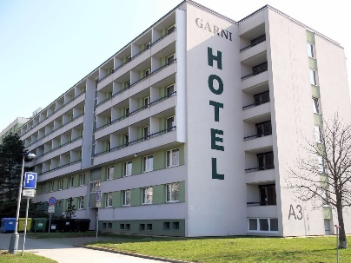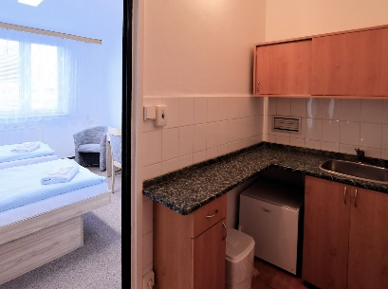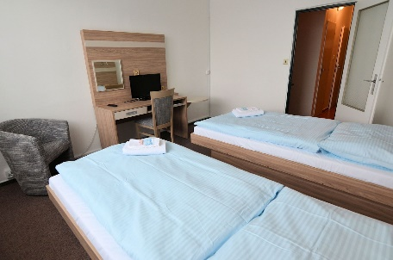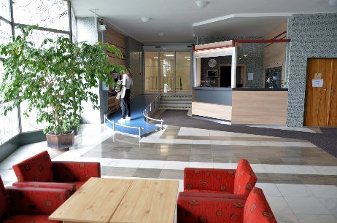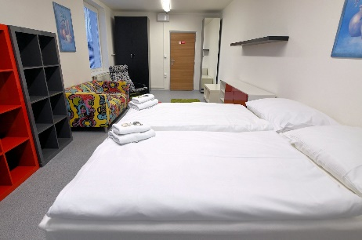

The Vinařkská Garni Hotel

Booking for MU guests
Klašková Ilona: | 549 49 2705
e-mail: | https://www.skm.muni.cz/hotel/garni-vinarska?en  hotel.vinarska@skm.muni.cz

Contact information
Address: | Vinařská 470/5c, 603 00 Brno
Reception: | 549 49 2713

You can find us
Near Brno Exhibition Centre (BVV). The connection from the city centre is from the main train station by tram No. 1 (Lipová stop), or from the Bohunice University Campus by trolleybus No. 25.
You will need ticket for 25 CZK
/1 euro/.

Cars can be parked in the car park near the Garni Hotel.

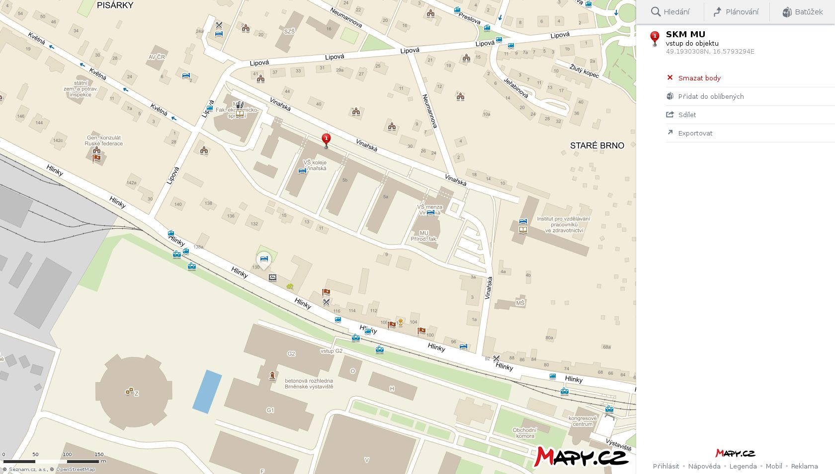
BRNO CENTRE
TROLEYBUS STOP LIPOVÁ # 25
RECEPTION: VINAŘSKÁ 5C
THE BOHUNICE UNIVERSITY CAMPUS

TRAM STOP LIPOVÁ # 1

